FOR DRIVERS
PLEASE PROVIDE ALL THE DOCUMENTS
LISTED BELOW

- LICENSE
- SOCIAL SECURITY
- LAST 3 YEAR DMV PRINT OUT
- TRUCK MEDICAL
- GREEN CARD / WORK PERMIT
- DOWNLOAD KEEP TRUCKING APP
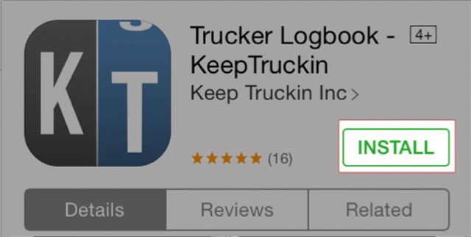

- DOWNLOAD PCS MOBILE APP
